Top-Down Parsers, Instruction Emission
The significance of parse trees is multifaceted:
- Intermediate code is generated from structures of parse trees and semantic information encoded in them.
- Type checking (for statically typed languages) and semantic analysis rely on the syntactic structures represented by parse trees.
- Syntax errors are detected by failure to construct parse trees.
- Pure interpreters interpret parse trees directly.
- Syntax-directed editors build a parse tree as the user types in a program. As a result, it can detect syntax errors on the fly and guide the program writing process by predicting and presenting syntactic patterns.
Two major parsing methods are used in programming language implementations:
- Top-Down, Recursive-Descent Parsers. Parse trees are constructed from the root downward by a collection of recursive functions. The recursive functions have direct structural correspondence to the BNF/EBNF grammar's production rules, and their actions are intuitively understandable. This method is suitable for hand coding of parsers. Parse trees might be constructed not in actual data structures but implicitly in the trees of function calls. Top-down parsers cannot be constructed from left-recursive production rules.
- Bottom-Up Parsers. Parse trees are constructed from the leaf nodes upward by a "shift-reduce" process using an action table and a stack. Generally, bottom-up parsers can issue better syntax error messages than top-down parsers. This method is too complex for hand coding, but is highly amenable to automatic generation of parsers from BNF/EBNF grammars. A popular automatic parser generator YACC system, for example, uses this method. Bottom-up parsers can be constructed from left-recursive production rules.
In this course only top-down parsers will be reviewed. We begin with an example top-down parser for the following grammar for arithmetic expressions:
<E> → <term> [(+|−) <E>] // equivalent to <E> → <term> | <term> + <E> | <term> − <E>
<term> → <primary> [(*|/) <term>] // equivalent to <term> → <primary> | <primary> * <term> | <primary> / <term>
<primary> → <id> | <int> | <float> | − <primary> | "(" <E> ")"
The category <primary> incorporates the unary − operator, which has the highest precedence.
We assume that the getToken() function is given to extract the next token and assign it to the string variable t. In the above grammar, the tokens are <id>, <int>, <float>, +, −, *, /, (, ). We create a function for each non-token category and code its body in a way that mirrors the right-hand side(s) of its production rule(s). Each function will parse strings in the corresponding category. In the above example, we create functions E(), term(), and primary(). To ease consistent calls to getToken(), we use the following convention:
- code so that the leading token is already in the variable t whenever a parsing function is called;
- each parsing function always extracts the next token just before returning.
void E()
{
term();
if ( t is "+" || t is "−" )
{
getToken();
E();
}
}

void term()
{
primary();
if ( t is "*" || t is "/" )
{
getToken();
term();
}
}

void primary()
{
if ( t is <id>, <int>, <float> )
getToken();
else if ( t is "−" )
{
getToken();
primary();
}
else if ( t is "(" )
{
getToken();
E();
if ( t is ")" )
getToken();
else
print("Error: ) expected");
}
else
print("Error: <id>, <int>, <float>, −, or ( expected");
}

The production rules for <E> and <term> can be given in iterative form:
<E> → <term> {(+|−) <term>}
<term> → <primary> {(*|/) <primary>}
The E() and term() functions are then coded with while-loops to mirror the iterative structure:
void E()
{
term();
while ( t is "+" || t is "−" )
{
getToken();
term();
}
}

void term()
{
primary();
while ( t is "*" || t is "/" )
{
getToken();
primary();
}
}
In order to derive top-down parsers, the production rules must be given in a form that clearly shows the functions to be called and the actions to be taken. In particular, left-recursive production rules should not be used since they may fail to show the functions to be called and the actions to be taken, or recursive functions derived from them may fall into infinite loops. (Bottom-up parsers can handle left-recursive rules without problems.) The production rules for each category <X> need to be combined into a single rule of the form:
<X> → α₁ | α₂ | ··· | α_{n}
If n ≥ 2, the processing of multiple α_{i} needs to be coded by a chain of conditional statements where the testing for choices is done by inspection of the leading tokens of α_{i}. The iterative constructs { ··· } and { ··· }⁺ are coded by suitable while-loops.
Emission of Intermediate Code Instructions We illustrate emission of intermediate-code instructions using a simple, abstract instruction set for a stack-based virtual machine. Although simple, it captures the core idea of stack-based machines. The following table describes the instructions and their actions (the "stack" refers to the operand stack):
push <id> : push the value of variable <id> onto the stack
push <const> : push the constant literal <const> onto the stack
pop <id> : pop the top of the stack and store it in variable <id>
add : pop the top two values of the stack, compute stack[top−1]+stack[top],
and push the value onto the stack
sub : pop the top two values of the stack, compute stack[top−1]−stack[top],
and push the value onto the stack
mul : pop the top two values of the stack, compute stack[top−1]*stack[top],
and push the value onto the stack
div : pop the top two values of the stack, compute stack[top−1]/stack[top],
and push the value onto the stack
neg : pop the top value of the stack, compute −stack[top], and push the value onto the stack
In this virtual machine, the virtual memory simply consists of a set of identifiers, and all expression evaluation occurs in the stack.
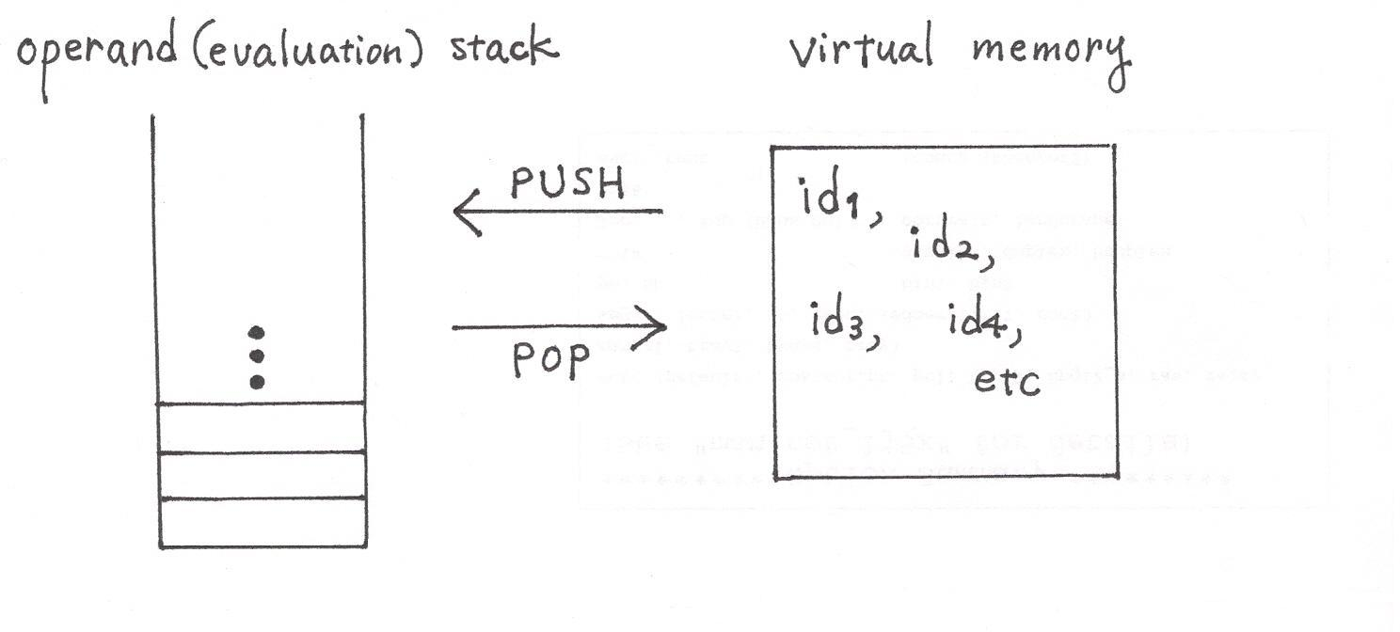
In stack-based machines (whether virtual or real hardware), each instruction implementing an operator f with n operands pops the top n values of the stack, compute f(stack[top−n+1], ..., stack[top]), and pushes the value onto the stack.
A merit of this type of stack-based instructions is that the pattern of their emission is described by a succinct operational schema. Let E be an expression to be compiled. The following recursive pattern is used to emit instructions to evaluate E:
if E is an identifier or a constant literal a, emit push a;

if E a compound expression f(E₁, ..., E_{n}), then

emit instructions for E₁;
...
emit instructions for E_{n};
emit the instruction for the operator f;
This pattern is easily implemented by postorder traversal of parse trees. Postorder traversal of the parse tree representing f(E₁, ..., E_{n}) traverses the parse subtrees for E₁, ..., E_{n} recursively in postorder, then visits the operator f. Whenever an identifier or a constant literal a is visited, emit push a, and whenever an operator is visited, emit the corresponding instruction. Execution of the emitted instructions will place the value of E at the top of the stack.
For example, the following parse tree for A+B*C
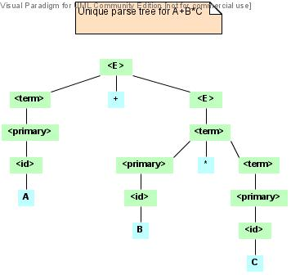
would generate:
push A
push B
push C
mul
add
The assignment statement schema x = E is compiled by the following pattern:
emit instructions to evaluate E // puts the value of E at top of the stack
emit pop x
The parsing functions, such as E(), term(), primary() above, might implicitly construct parse trees in the form of trees of function calls. The crucial fact here is that the temporal order of function calls corresponds directly to that of postorder traversal of (implicit) parse trees, and the correspondence is manifest in the functions' body code. Instruction emission of such top-down parsers takes advantage of this fact. The following code incorporates instruction emission into the right-recursive version of E(), term(), and primary(); generated instruction streams will use right-associativity for the binary operators +, −, *, /. Note how operator instructions are emitted after instruction emissions of their arguments.
void E()
{
term(); // generates instruction stream for <term>
if ( t is "+" || t is "−" )
{
saved_t = t;
getToken();
E(); // generates instruction stream for <E>
// now generate the operator instruction to compute <term>(+|−)<E>
if ( saved_t is "+" )
emit add;
else
emit sub;
}
}

void term()
{
primary(); // generates instruction stream for <primary>
if ( t is "*" || t is "/" )
{
saved_t = t;
getToken();
term(); // generates instruction stream for <term>
// now generate the operator instruction to compute <primary>(*|/)<term>
if ( saved_t is "*" )
emit mul;
else
emit div;
}
}

void primary()
{
if ( t is <id>, <int>, <float> )
{
emit push t;
getToken();
}
else if ( t is "−" )
{
getToken();
primary(); // generates instruction stream for <primary>
// now generate neg to compute −<primary>
emit neg;
}
else if ( t is "(" )
{
getToken();
E(); // generates instruction stream for <E>
if ( t is ")" )
getToken();
else
print("Error: ) expected");
}
else
print("Error: <id>, <int>, <float>, −, or ( expected");
}
The following incorporates instruction emission into the iterative version of E() and term(); generated instruction streams will use left-associativity for the binary operators +, −, *, /.
void E()
{
term(); // generates instruction stream for <term>
while ( t is "+" || t is "−" )
{
saved_t = t;
getToken();
term(); // generates instruction stream for <term>
// now generate the operator instruction to compute (accumulated result for preceding <term>s)(+|−)<term>
if ( saved_t is "+" )
emit add;
else
emit sub;
}
}

void term()
{
primary(); // generates instruction stream for <primary>
while ( t is "*" || t is "/" )
{
saved_t = t;
getToken();
primary(); // generates instruction stream for <primary>
// now generate the operator instruction to compute (accumulated result for preceding <primary>s)(*|/)<primary>
if ( saved_t is "*" )
emit mul;
else
emit div;
}
}
In class we also discussed emission of the pop instruction in assignment().
In real-world stack-based virtual machines such as the Java Virtual Machine and the Common Intermediate Language, the push and pop instructions are respectively called load and store.

